Baseline Analysis

# Questions:

1. Phases of ADNI and Longitudinal Follow ups:
   1. Should we consider only ADNI1 or ADNI2 as the baseline? Or can we incorporate baseline data from all the phases as long as they are followup visits for those participants?
   2. How many participants have longitudinal data with multiple ADNI phases?
2. MRI versions and preprocessing considerations:
   1. What are the different MRI acquisition protocols and preprocessing pipeline versions?
   2. Can we ensure that the MRI versions remain consistent or how does other literature use different MRI versions?
3. Diffusion Tensor Imagining Availability:
   1. How many participants across ADNI phases have DTI scans available? And are those protocols consistent across ADNI phases?
4. Sociodemographic Considerations:
   1. How well are sociodemographic factors such as ethnicity, income, education level represented in ADNI?
   2. Can we account for regional disparities in sleep quality?
   3. Do we have information on conditions such as sleep apnea or hypoxia, and how these affect the sleep disturbances?
5. Visit Lags:
   1. How frequently are MRI and sleep questionnaire data collected for each participants across follow up visits?
   2. How many participants have missing data for MRI, sleep or other biomarkers in follow-up visits
6. Alluvial Plot:
   1. Visualizing the transition of participants across Diagnosis using an alluvial plot

# Analyses:

If we incorporate the baseline data from all the phases, we have about 1971 participants with more than 2 total visits (including baseline) from the total 2430 participants (2419 available participants).

The Best approach is to use all available ADNI baselines while ensuring longitudinal follow-ups with more than 2 visits from baseline exists.

|  |  |  |  |
| --- | --- | --- | --- |
| Baseline | Converted? | Number of participants | Final |
| AD | No | 405 | AD |
| AD | Yes | 6 | MCI |
| CN | No | 432 | CN |
| CN | Yes | 19 | Dementia |
| CN | Yes | 91 | MCI |
| EMCI | No | 301 | EMCI |
| EMCI | Yes | 56 | CN |
| EMCI | Yes | 65 | Dementia |
| EMCI | Yes | 1 | MCI |
| LMCI | No | 338 | LMCI |
| LMCI | Yes | 39 | CN |
| LMCI | Yes | 312 | Dementia |
| LCMI | Yes | 1 | MCI |
| SMC | No | 317 | SMC |
| SMC | Yes | 4 | Dementia |
| SMC | Yes | 32 | MCI |

Total Follow-up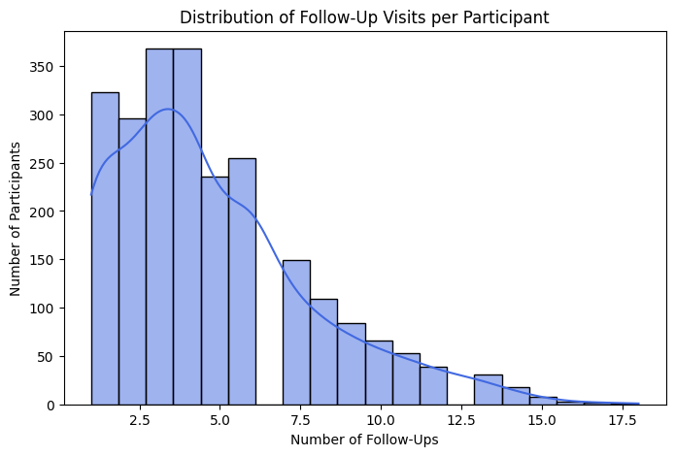 visits per participant:

This suggests that, Number of follow-ups should be around 3-4 to get the most out of longitudinal study. (6 months, 12 months, 24 months and/or, 48 months).

The ADNI MRI protocol is updated every new grant cycle. The current ADNI 4 consists of nine different series types.

The ADNI1 (2004-2009) focused on structural imaging using 1.5T scanners.  
The ADNI2/GO (2009-2016) introduced to use the 3T scanners.  
The ADNI3 (2016-2023) conducted entirely at 3T.  
The ADNI4 Aims to maintain longitudinal consistency while adopting new technologies.  
ADNI used consistency MRI data acquisition method across sites and over time, including achieving similar image qualities: contrast-to-noise ratio, spatial resolution, and resistance to artifacts across sites.

The approaches to issue the scanner changes:  
1. Assuming that longitudinal within participant data is not compatible before vs after a change in scanner.  
2. Assuming that longitudinal within participant data is not compatible before vs after a major hardware change.  
3. Assuming that longitudinal within participant data maybe compatible before vs after a software version change but being advised that this may not be shown to be true eventually for some types of software changes.

However, A study file has the subcortical brain region volumes is available across different ADNI phases:

UCSFFSL – Freesurfer-based MRI measurements derived from a longitudinal analysis (collected across multiple time points for each participant)

UCSFFSX – Represents the same MRI measurements but from a cross-sectional analysis, looking at the data from a single time point for each participant.

Methods – FreeSurfer version 5.1 was used- input data were processed using the 2010 Desikan-killany atlas and the 2009 Destrieux atlas.

ADNI1 1.5T data was run with FreeSurfer version 4.3 and ADNI1 3T was run with version 5.1

Cross sectional FreeSurfer:

Version 7.x was used to process ADNI1, GO, 2, 3, and 4.  
 Version 5.1 was used to process ADNI1, Go and 2.  
 Version 4.3 was used to process ADNI1, Go and 2.

Longitudinal FreeSurfer:

Version 4.4 was used to process ADNI1, Go and 2.  
 Version 5.1 was used to process ADNIGO and 2.

*FreeSurfer version 4.3 to 4.4 has only minor changes containing bug fixes related to longitudinal analysis stream.

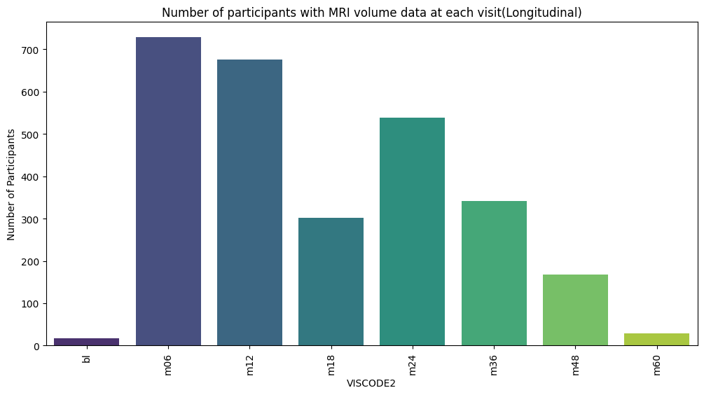

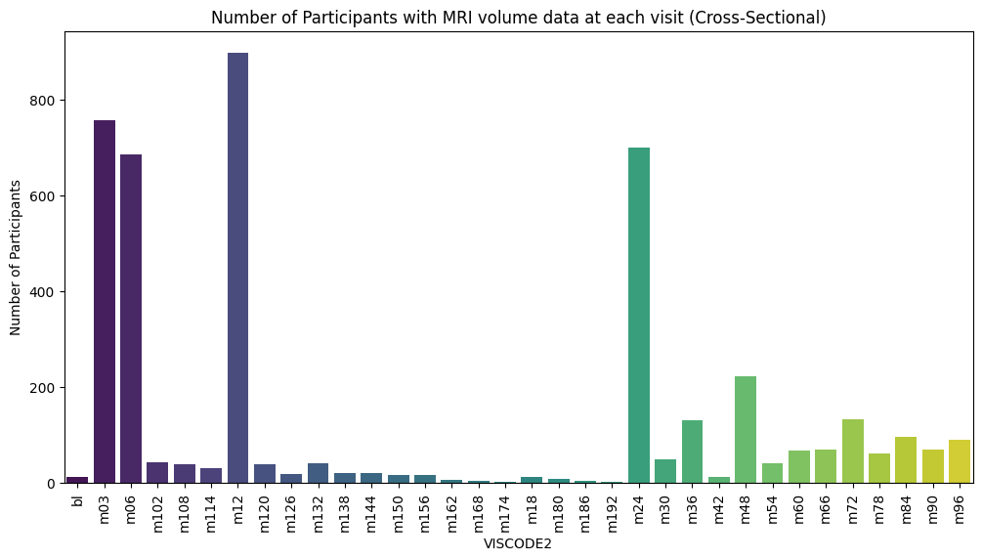Demographics such as: Age, Gender, Education, Ethnicity, Race, Martial status has been considered.

| **(DX_bl)** | **Mean Age (±SD)** | **Gender (Male / Female)** | **Education (Years, Mean ± SD)** | **Ethnicity** | **Race** | **Marital Status** |
| --- | --- | --- | --- | --- | --- | --- |
| **AD** | 74.75 ± 7.94 | 231 / 180 | 15.22 ± 2.90 | Not Hisp/Latino: 393, Hisp/Latino: 15 | White: 375,  Black: 22,  Asian: 10,  More than one: 4 | Married: 347, Widowed: 39, Divorced: 14, Never married: 11 |
| **CN** | 73.33 ± 6.35 | 255 / 286 | 16.41 ± 2.62 | Not Hisp/Latino: 514, Hisp/Latino: 25 | White: 476,  Black: 47,  Asian: 13,  More than one: 2, Indian/Alaskan: 2 | Married: 369, Widowed: 80, Divorced: 58, Never married: 33, Unknown: 1 |
| **EMCI** | 71.20 ± 7.48 | 227 / 194 | 16.00 ± 2.65 | Not Hisp/Latino: 396, Hisp/Latino: 23 | White: 381,  Black: 18,  More than one: 8, Asian: 7,   Indian/Alaskan: 2, Hawaiian/Other: 1 | Married: 320, Divorced: 47, Widowed: 30, Never married: 20, Unknown: 4 |
| **LMCI** | 73.74 ± 7.49 | 421 / 267 | 15.97 ± 2.84 | Not Hisp/Latino: 661, Hisp/Latino: 24 | White: 627,  Black: 39,  Asian: 12,  More than one: 4, Hawaiian/Other: 1, Indian/Alaskan: 1 | Married: 533, Widowed: 80, Divorced: 59, Never married: 14, Unknown: 2 |
| **SMC** | 70.58 ± 6.77 | 133 / 220 | 16.69 ± 2.33 | Not Hisp/Latino: 323, Hisp/Latino: 28 | White: 272,  Black: 50,  Asian: 16,  More than one: 12, Unknown: 3 | Married: 245, Divorced: 47, Widowed: 39, Never married: 20, Unknown: 2 |

The MRI brain volume regions from both UCSFFSL and UCSFFSX taken separately, merged with the ADNIMERGE data containing the Insomnia symptoms column to check the Follow-up distribution.

